|  |  |
| --- | --- |
|  | Project: Proposal |
|  | Assessment 1: |
|  | Mitchell Bellamy (BEL13374080)  Project (CMP3060M)  10/16/15 |

Contents

1. Introduction 2

1.1. OBS Plugin to overlay key presses 2

1.2. Research Methods 2

1.3. Tools 2

2. Aims and Objectives 3

2.1. Aim 3

2.2. Objective - 3

3. Literature Review 4

3.1. 4

3.2. 4

4. Project Plan 5

4.1. Direction of the project 5

4.2. Gantt Chart 5

4.3. Risk Matrix 5

5. References 6

# 1. Introduction

## 1.1. Project Domain and Rationale

This project involves elements of software development, open source integration, human-computer interaction and design. Many of these aspects will be tackled in some way throughout the introduction and explained as to why they are important areas for the project and what will be done to fulfil them.

It is these aspects and the ability to produce a deliverable to users across the globe that made this project desirable. On top of that, it provides good grounds to gain experience of working in the open source sector of industry which can improve employability and software knowledge.

This project outlines the requirement to develop a plugin (software) for Open Broadcaster Software (OBS). OBS is a program that allows the user to stream a video feed live to the internet (through services such as Twitch.tv and Livestream.com). This plugin is to display relevant keystroke information to viewers of the stream.

## 1.2. OBS Plugin to overlay key presses

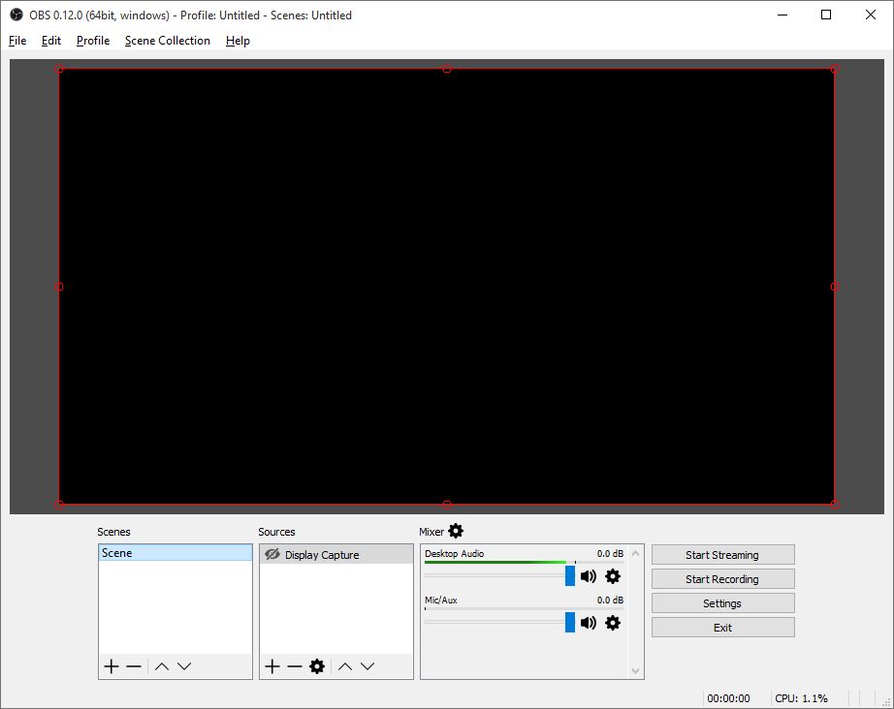Open Broadcaster Software (OBS) is an open source program developed for people to record and/or live stream video from their computer to services such as Twitch.tv and livestream.com. The use case scenarios are vast for live streaming, such as festivals, talk shows, games, podcasts and more. In particular, live streaming from home on a computer has become exceptionally popular with consumers and content creators over the last couple of years (citation needed). This high growth and uncertain future makes the streaming community a very interesting area for new research and development.

Figure 1: OBS Studio 0.12 on Windows.

OBS Studio allows the user to both stream and record video. More uniquely, is that as a streaming software package, it offers ‘scenes’ and ‘sources’ which can help create independent windows to help separate what the streamer sees on their computer to what the viewers see online. This is something that will need to be considered and incorporated to help empathise with the viewers and users independently.

Even now ‘live streaming’ video games in particular can be a very heated topic. There are many who believe ‘e-sports’ are now mainstream or soon to be widely accepted (citation needed). The community surrounding just e-sports are extremely passionate and consistently consume this media. One of the more interesting growth areas for this project to look into however is those that watch professional players to learn how to play better for themselves. Furthermore, for those that record tutorial videos with OBS for computer software for example, have very limited options in displaying shortcuts or key presses to help viewers learn more efficiently. These are just two scenarios that would benefit from a plugin to overlay key presses during live streaming and recording.

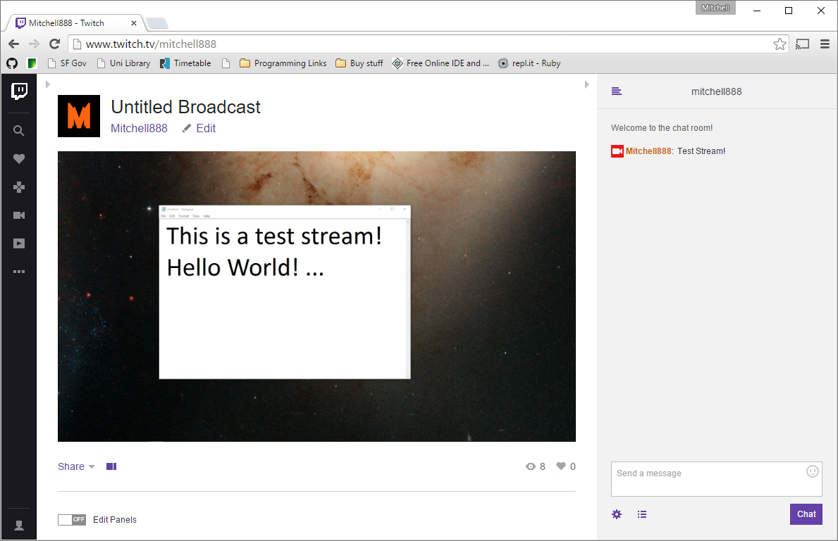Twitch.tv is just one of the many services that offer to host live streaming, along with YouTube and Livestream.com. Twitch.tv however has a primary focus on gaming and related content (such as music, software and talk shows). YouTube also has a live streaming sub-site which focuses on gaming content only, whereas Livestream.com aims to host live events.

Figure 2: A quick test stream on Twitch.tv

For this project, Livestream.com is somewhat out of scope as it is unlikely that live events would benefit from a key overlay. Therefore, the aim of this project will target services similar to and including Twitch.tv. This helps to define a domain and scope for the aim, which will help to create potential focus groups or for testing purposes.

As for the plugin itself which is to be developed in C++ on the latest version of OBS Studio, will be required to effectively display relevant keystrokes to the viewer but not overlay this information on the streamers machine as to avoid distraction and clutter. The streamer will always be able to see what the viewers see through OBS Studio itself.

The design of the key overlay needs to display information in such a way that is helpful to viewers so that they can follow the streamers actions (and reactions) in a way that has not been possible before. The display of this information is something that will need to be researched, trialled and tested to ensure it delivers the aim to the viewers.

## 1.2. Research Methods

Ethnography, Observation of Streaming and use of software.

Interviews, including Focus Groups.

Emulating user, learn how to use OBS/Studio

Previous plugins/workarounds

Other Programs and their plugins: Blender

Literature Review Research Methods?

Research through Making/Design

## 1.3. Tools

Many of the tools associated with this project are aimed at assisting development in an effective way. Especially for peace of mind and security, GitHub and OneDrive will both be used as to not place sole reliance on any one system.

GitHub (Github Inc, 2015) is a service based on git for version control. Version control is extremely useful for Open Source developments, documentation and sharing of code. Having a repository on GitHub will make the final plugin much more accessible

OBS and the community forums

Visual Studio

Cmake

Github / OneDrive

# 2. Aims and Objectives

## 2.1. Aim

The aim of this project is to develop a plugin which enables the user to display their corresponding keystrokes on a video recording (including live streaming) via Open Broadcaster Software (OBS).

For e-sports enthusiasts, gamers and spectators.

For viewers of software based tutorials.

## 2.2. Objectives

1. Conduct further artefact research

In order to correctly identify critical features of the plugin, it is essential to perform some elements of Human-computer studies to evaluate how the plugin should be designed. Amongst this, it should also influence the graphical interface of the plugin to ensure excellent usability. This research may include; Observations, Surveys, User Studies and evaluations of other implementations.

1. Setup Development Environment and build

To begin development, the environment and dependencies need to be in place according to the standards set by the community for OBS Studio. Within this objective is the requirement to setup CMake (A solution building tool for cross-platform development) for cross-platform support.

It should be noted that there are also coding standards for C++ that OBS Studio is written in and therefore should be followed closely to ensure it can be easily documented and understood.

1. Implement key features

Some requirements gathering will occur naturally during further research, observations and surveys. However, there are some aspects of this project that must be met. These are;

* Key Presses are displayed to the viewer in some meaningful way.
* Do not store system wide key presses.
* Contributes to the Open Source community.
* Must interact with OBS Studio.

These requirements are somewhat flexible, but it is these aspects that provide the scope and domain for the plugin development.

1. User study and Testing

To help understand how the plugin would be used in a real scenario, a User study could provide excellent feedback to critique the plugin and provide insight into what could be improved in future iterations. Alongside this stage, testing can occur to ensure the plugin behaves as expected and adheres to the coding standards set by the community of OBS Studio.

1. Ensure plugin behaves ethically

The plugin must not *collect* keystrokes. This behaviour is typically reserved for ‘key loggers’ that attempt to store sensitive information by storing every key press. It is in the Users best interest that this behaviour is avoided in the plugin.

1. Project Report

# 3. Literature Review

## 3.1. Learning and Memory association

To support the aim of this project, research into areas of learning may guide software development and design to improve the plugins ability to help viewers memorise and implement key presses they see online. This area of research is particularly interesting as the viewers of such videos and live streams are unable to memorise these key presses through physical movement at the time of viewing.

Kawato et al motor control concept.   
Kawato, M., Furukawa, K. and Suzuki, R. (1987) Biol. Cybern. 57, 169–185

In the Journal article ‘Parallel neural networks for learning sequential procedures’ (Hikosaka et al, 1999, 465) a concept of procedural learning (learning how to perform new tasks) is proposed which does not ‘strictly’ rely on sensorimotor processes performed in sequence. Thus, it can be said that a viewer of a particular stream may be able to learn key presses through memorisation/recognition at the early stages of learning new movements but then form the association with motor control, its corresponding key press and the visual and/or auditory change on a computer monitor at a later time when performing the originally viewed action. This action could be a tricky manoeuvre in a video game, or a certain setting within an options menu. Further discussion around this topic support this view in the article ‘Role of action observation and action in sequence learning and coding’ (Boutin et al, 2010, 250) where the paper suggests “movement sequences acquired through observational practice are effector-independent and are coded in visual-spatial coordinates” which in theory the research should directly relate in such a way that the movement sequences are similar to several key presses to perform an action that is observed online, which during viewership will in theory be coded in the brain through visual-spatial memory.

Without the ability to know what keys were pressed at given moments in time as a response to visual and auditory stimuli, the parallel process Hikosaka et al propose might not begin unless the viewer was already fully experienced with the content of the video. E.g. a professional e-sports player watching another professional e-sports player (without a key overlay) would be much more successful in associating key presses due to their visual stimuli association of the action and its corresponding key press. Therefore, it would be beneficial to have the ability to display a stream of key presses to viewers to learn through observation visually. (Boutin et al, 2010).

To further support the aim and previous discussions; the results and summary from ‘Distinct modes of executing movement sequences: Reacting, associating, and chunking’ (Verwey and Abrahamse, 2012) show evidence of improved reaction times and the performance of participants through familiarisation of the tested sequences. Participants were also asked to repeat the sequence after the initial test, indicating that more people succeeded in recognising the sequence rather than recalling from memory. This combination of repeated exposure to a sequence and the increased ability to recognise that sequence visually provides promising grounds to develop this plugin in such a way that aids the chunking of key presses into sequences associated with goals.

These articles provide very positive reasoning for such a plugin to exist but there are certain aspects out of the scope of this project that need to be discussed. One of which is mentioned in ‘Learning a keying sequence you never executed: Evidence for Independent associative and motor chunk learning’ (Verwey and Wright, 2014, 29) which discusses that learning keying sequences from observation association is improved when accompanied with motor chunking (physically using and learning the key presses overtime). This indicates that over time the key overlay may become less useful to viewers who watch only one person, as the viewer will eventually become accustomed to the observation and will later in learning move to a motor chunk method of recalling the key sequences. It is not to say however that this is a negative point as recalling movements through motor chunking Is often shown to be faster in research results (Boutin et al, 2010; Verwey and Abrahamse, 2012; Verwey and Wright, 2014) which have been learned over time through physical practice. Therefore it may be recommended to users of this plugin that actual practice of the observed key sequences will increase the rate of procedural learning.

Many works and researchers have indicated that those who play video games are better at certain performance based tasked than those who do not play video games.

VAK Learning / How do people learn?

Discuss; Ergonomics, Similar products, Similar plugins

Adding more information to a stream, E.g. adding text into a video byte stream.

Statistics and userbase.

## 3.2. Other products

//contributes to the chosen methods/tools/techniques

HCI related literature on Ethnography/Observation and Interviews.

# 4. Project Plan

## 4.1. Direction of the project

## 4.2. Gantt Chart

## 4.3. Risk Matrix

|  |  |  |  |
| --- | --- | --- | --- |
| **Risk** | **Likelihood** | **Impact** | **Mitigation** |
| Personally being ill or unable to work. | Low | Due to the nature of this project being predominately desk based, the impact will be minimal. | Ensure work is not done in bulk, but progressively each week. |
| Delays and issues to setting up Plugin Development. | High | Until this hurdle is overcome, it could have a medium-high impact on the start of the project. | Abundance of open source assistance available and University staff to assist if needed. |
| Supervisor unavailable due to illness | Moderate | As the project spans for several months, it is moderately likely that the supervisor may be unable to attend a meeting or respond appropriately due to illness. | Ensuring that work moves at a consistent steady pace so that any one meeting does not become more critical than another. |
| OBS Studio Development Issues | High | Slowed development and harder implementations of features and cross-platform compatibility. Moderate impact. | Target only Windows initially to ensure at least one version works. Join the Open community as documentation is lacking. |
| CMake Development issues | Moderate | Slower initial development until it has been setup. Minimal impact. | Assistance with Supervisor and online Documentation to speed up the process. |
| Problematic implementation | High | It is very likely that implementing a particular function/feature will be almost impossible due to how new OBS Studio is, and that it is not feature complete. | This will have to be mitigated by developing workarounds or simply putting features on hold until development progresses. |
| Home computer breaks. | Low | Low impact to work however the schedule and plan may need to adapt. | GitHub repository and OneDrive will keep independent copies to ensure there is no data loss to work, including documentation. |
| Updates to OBS Studio cause issues to plugin | Moderate | Moderate impact, unforeseen updates may create new roadblocks for development. | If this becomes too big of an issue, development may have to be kept on one version until OBS matures. |
| Unable to implement full plugin within OBS Studio | Low | High impact, the project will have to target another version or stand alone. | If this occurs, then development will need to target an old version of OBS or write a standalone program. |
| Loss of work. | Low | High impact. | All associated work (including the artefact) will be stored on a private repo on GitHub and OneDrive. |
| Missed objective deadlines. | Low | Moderate Impact | Development for certain objectives may take longer to implement due to bad estimations or unforeseen issues, avoiding these where possible. |
| Users dislike the final artefact product | Low | High Impact to success of plugin, but will still yield useful results. | To prevent the final product from not fulfilling the aim confidently, testing and research will be done frequently as iterations are created. |

Combine closely related Risks!!

# 5. References

**There are no sources in the current document.**

Reference List

Verwey, W.B. and Abrahamse, E.L. (2012) Distinct modes of executing movement sequences: Reacting, associating, and chunking. *Acta Psychologica,* 140(3) 274-282.

 Reference List

Boutin, A., Fries, U., Panzer, S., Shea, C.H. and Blandin, Y. (2010) Role of action observation and action in sequence learning and coding. *Acta Psychologica,*135(2) 240-251.

Green, C.S. and Bavelier, D. (2008) Exercising your brain: A review of human brain plasticity and training-induced learning. *Psychology and Aging,*23(4) 692-701.

Hikosaka, O., Nakahara, H., Rand, M.K., Sakai, K., Lu, X., Nakamura, K., Miyachi, S. and Doya, K. (1999) Parallel neural networks for learning sequential procedures. *Trends in Neurosciences,*22(10) 464-471.

Verwey, W.B. and Abrahamse, E.L. (2012) Distinct modes of executing movement sequences: Reacting, associating, and chunking. *Acta Psychologica,*140(3) 274-282.

Verwey, W.B. and Wright, D.L. (2014) Learning a keying sequence you never executed: Evidence for independent associative and motor chunk learning. *Acta Psychologica,*151 24-31.

GitHub Inc. (2015) *Github Where Software Is Built.* [online]. Available from <https://github.com/> [Accessed 06 Nov 2015].

Microsoft (2015) *OneDrive – Cloud storage from Microsoft.* [online]. Available from <https://onedrive.live.com/> [Accessed 06 Nov 2015].

Twitch.tv statistics and boast pages:

<http://www.twitch.tv/year/2014>

<http://www.twitch.tv/year/2013>

* <http://www.businessinsider.com/statistics-about-twitch-2014-8?IR=T>

<http://bambooinnovator.com/2014/02/04/apple-quietly-builds-new-networks-stitching-together-a-network-of-internet-infrastructure-capable-of-delivering-large-amounts-of-content-to-customers-giving-the-company-more-control-over-the-distrib>

* 1.8% internet traffic compared to Apple, google, Netflix.

Other products:

<http://www.tobii.com/xperience/>

* Eye tracking.

Other plugins: (not OBS Studio)

<https://obsproject.com/forum/threads/tool-streamkb-onscreen-keyboard.4789/>

<https://obsproject.com/forum/threads/nohboard.12637/>

<https://www.youtube.com/watch?v=FB8bFf__kjg>

* Also in: <https://www.youtube.com/watch?v=L4xEhEsju8o>

Streamers:

<http://www.twitch.tv/spareosu/v/23311853>

* A streamer using two webcams to show keypresses